Menu | Date  Event Name
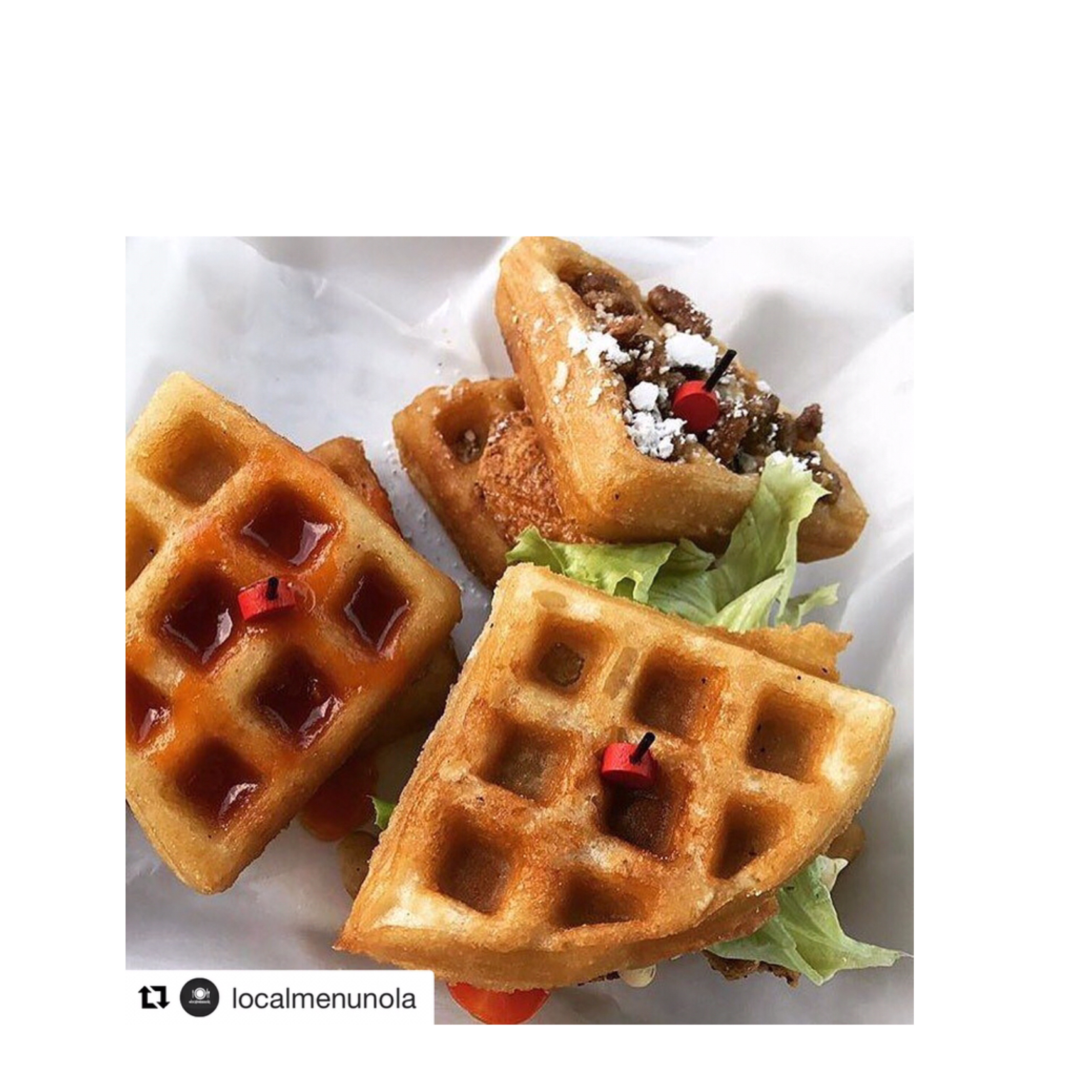  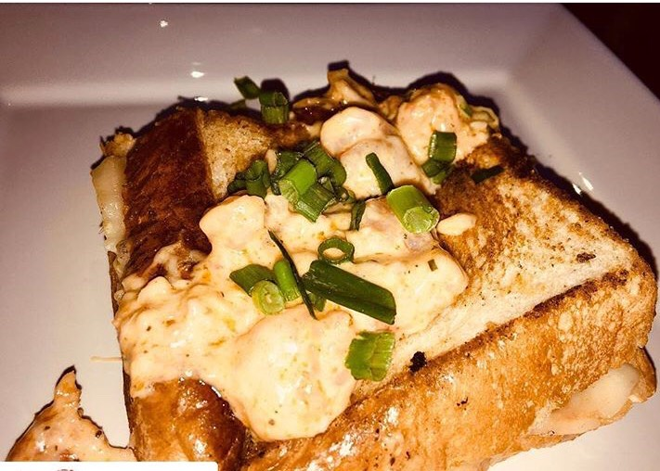  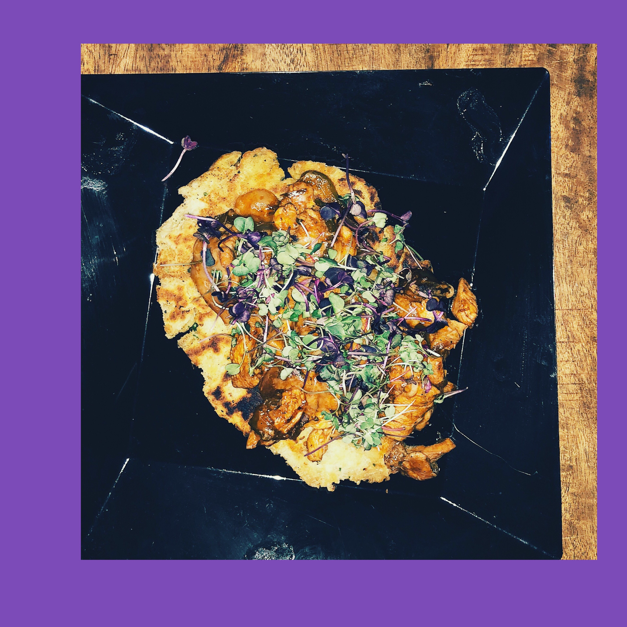 | Menu Item Name  Chicken and Waffles  Sweet –Fried Cake Batter Waffle, Bourbon Maple Syrup, Candied Pecans,  NOLA fried chicken  Savory- Fried Cake Batter Waffle, Campari Tomato, Dill Aioli, Leaf Lettuce, Clausen sandwich pickle. NOLA fried chicken  Spicy- Fried Cake Batter Waffle, Sriracha Pineapple sauce, Rainbow Fresno Chile slaw, NOLA fried chicken  Thai- Fried Cake Batter Waffle, Local Thai sauce, fresh herb slaw, Toasted sesame seeds,  NOLA fried chicken  Seafood Grilled Cheese  Grilled garlic butter marinated Local Seafood,  Shrimp, Crab, Crawfish  Asiago cheese, Italian herb corn bisque cream sauce  Toasted Texas Toast  Naan Flat Bread Pizza  Handmade pan seared Indian flat bread Grilled BBQ chicken thighs with homemade BBQ sauce sautéed green pepper and Vidalia onion medley, mozzarella cheese.  Caprese- Handmade pan seared Indian flat bread Grilled Roma tomato Basil Aioli, Balsamic tossed arugula, mozzarella cheese  Specialty Menu Items  25 minimum any flavor Chicken and Waffle sliders $125  25 minimum sandwiches Seafood Grilled cheese with Creole Corn Bisque cheese sauce  $100  25 minimum Naan flat bread pizza $100  $75 for veggie pizza  A la Carte Menu  Baked Mac n Cheese full size aluminum pan $75  100 pieces Chicken tenders $75  Assorted finger sandwiches 25 count $20  50 counts $30  100 counts $50  French Bread party sandwiches  25 counts $30  50 counts $40  100 counts $70  BBQ Meatballs 100 count $50  Jambalaya full size aluminum pan $100

